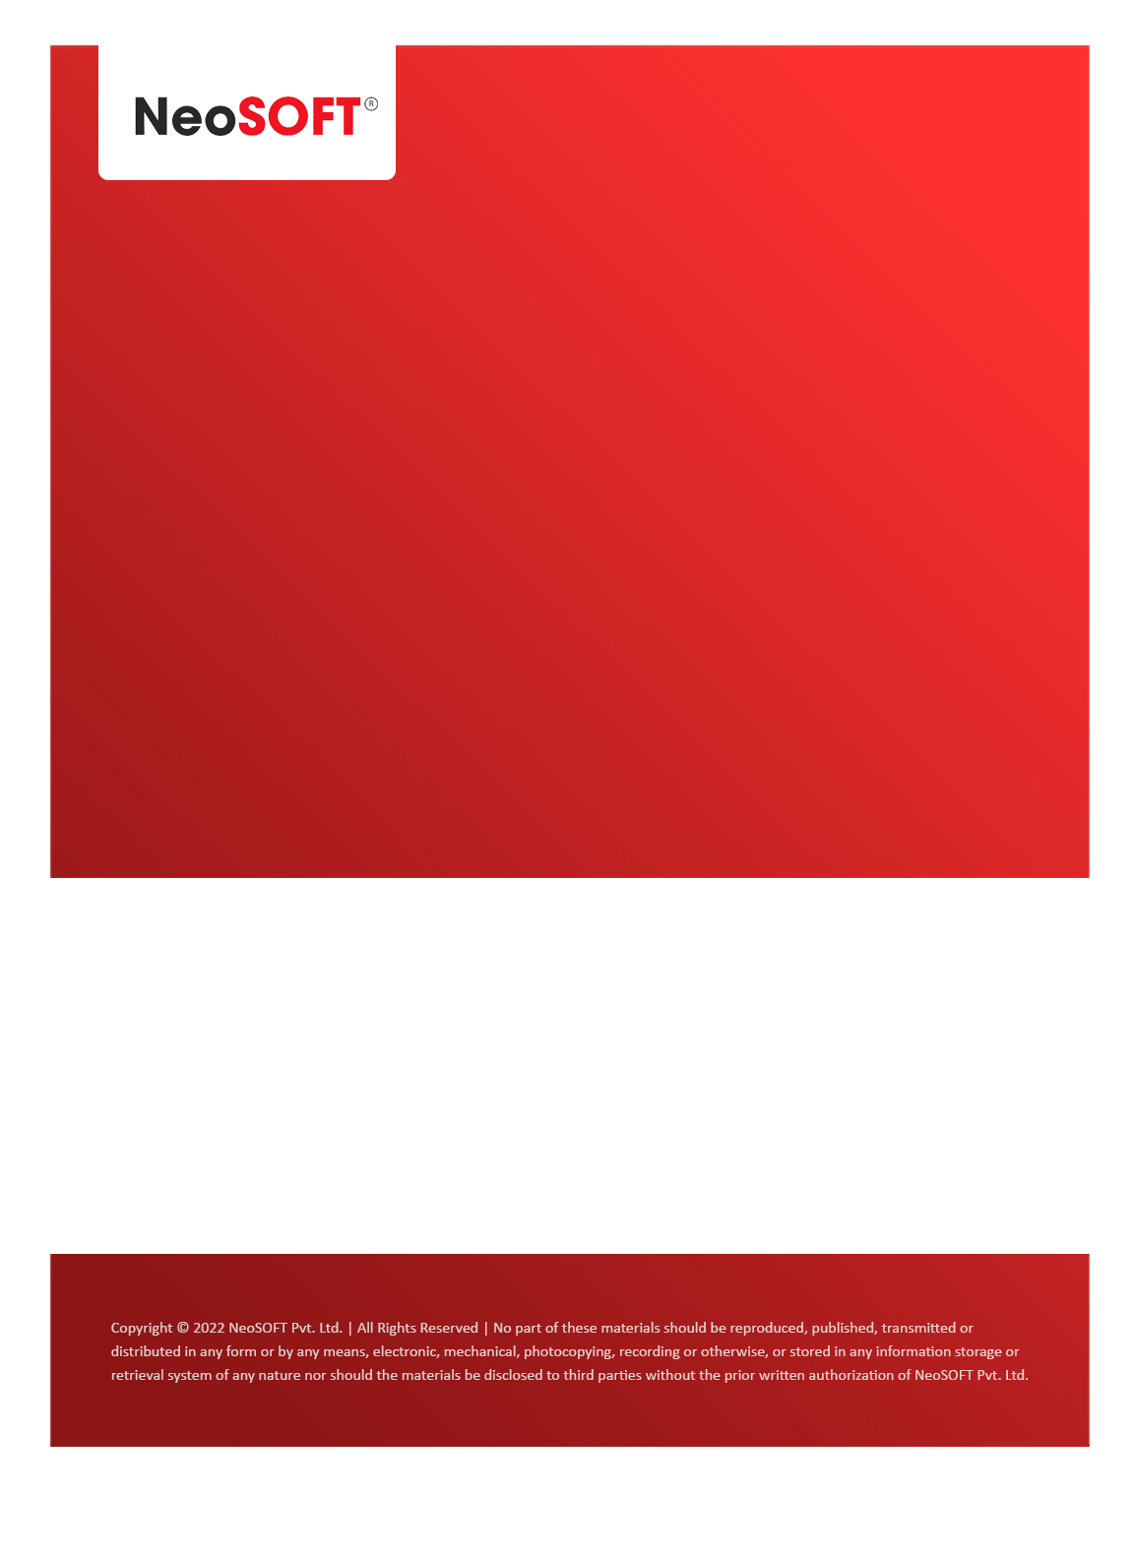`

**Eltizam MOM – Requirement Gathering meeting**

Eltizam

Client Name

NeoSOFT is a SEI-CMMI Level-5 Global IT Consulting & Software Solutions Provider

**April 28**, 2023

|  |  |
| --- | --- |
| **Meeting Date, Time, and Attendee Details** | |
| **Date** | 28th April 2023 |
| **Venue** | MS Teams |
| **Time** | 12.00 PM – 01.30 PM IST |
| **Meeting Type** | Wireframes review, Project status |
| **Internal Attendees** | * YallaReddy * Akshata Shinde |
| **Client Attendees** | * Karuna Pawar |
| **Presented By** | * Karuna Pawar |
| **MOM Prepared By** | * YallaReddy |

|  |  |
| --- | --- |
| **Details of Meeting** | |
| **Sr. No.** | **Description** |
| 1 | Discussed on submitted wireframes on top level. |
| 2 | Discussed Valuation process module’s payment, Invoice, term of engagements sub modules with Karuna. |
| 3 | Discussed Evaluation process module’s Valuation Instructor screen, Site Description screen, Comparable Evidences, Valuation Assessment sub modules with Karuna. |
| 4 | Akshata started working on implementing these module’s wireframe along with SRS documents. |
| 5 |  |

|  |  |  |  |  |  |
| --- | --- | --- | --- | --- | --- |
| **Actionable** | | | | | |
| **Sr. No.** | **Action Item** | **Assigned to** | **Assigned Date** | **Expected Completion Date** | **Status** |
| 1 |  |  |  |  |  |
|  |  |  |  |  |  |
|  |  |  |  |  |  |